Activity 2.5 Sketching Practice

Introduction
Sketching is a valuable engineering skill that needs to be developed through practice. Through practice you will be able to communicate your vision of your idea.

In this activity you will apply the skills that you learned earlier in this lesson to more complex objects.

Equipment
- Pencil

Procedure

Each of the following nets can be cut out and folded into a box. Note that there may be more than one square on each face of the box once constructed. Sketch an isometric pictorial sketch for each of the boxes formed.

1.

2.

- Create a one-point perspective of the object represented by the orthographic projections. Apply tonal shading.
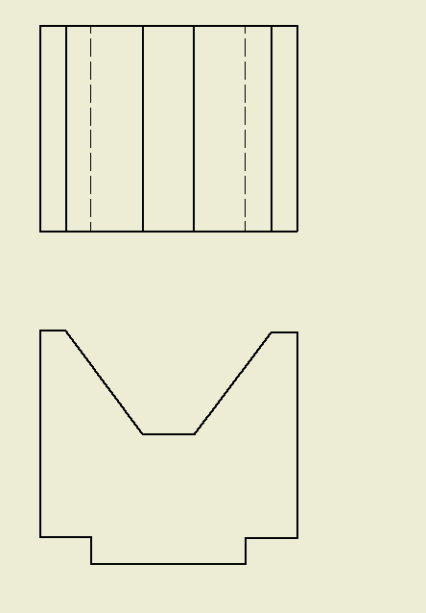

- Create an isometric view of the object represented by the multi-view. Apply tonal shading.

- Sketch a two-point perspective view of the object represented by the sketch. Apply tonal shading.
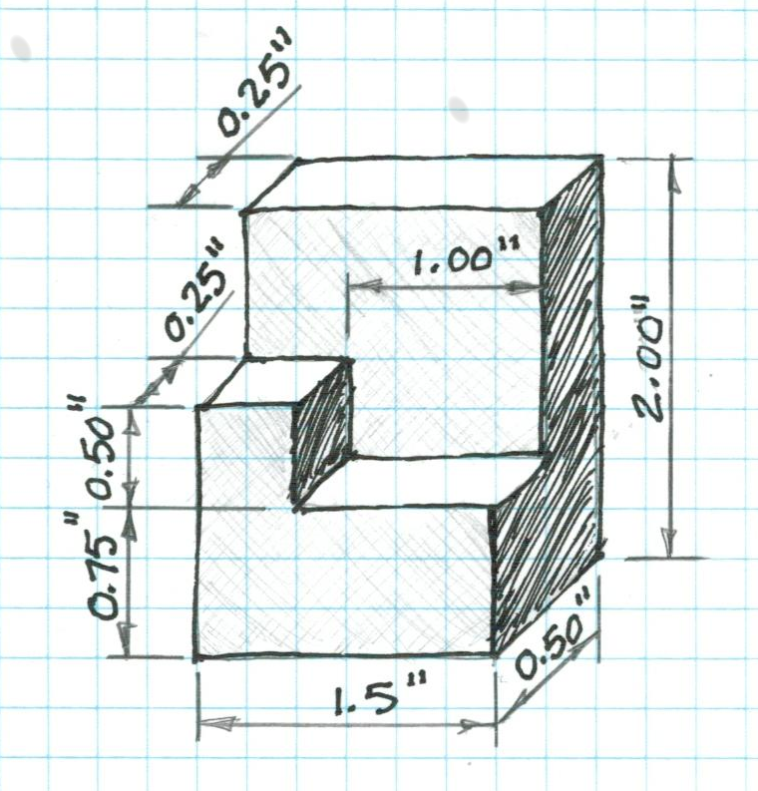

Conclusion
- What is a technical sketch? What is an artistic sketch? How are the two similar and how are they different?

- How do you envision applying your sketching skills in other classes?

- How do you envision applying your sketching skills in college?

- How would you teach sketching to a student next year?

