Activity 3.5 Applied Statistics

Introduction
Today’s consumers are constantly trying to judge the quality of products. But what is quality? How and by whom is quality determined? Some would say the designer creates specifications, which in turn dictate the quality of a product. That quality is also based on the acceptable value of a part within a whole product.
Statistics are commonly used in manufacturing processes to control and maintain quality. This activity will allow you to apply statistics in order to analyze and determine the quality of a set of wooded cubes.

In this activity you will collect data and then perform statistical analyses to determine measures of central tendency and variation of the data. You will also represent the data using a histogram.

Equipment
- Engineering notebook
- Pencil
- Dial caliper

Procedure
- Part of the manufacturing quality control testing for a toy is to measure the depth of a connector piece that must fit into another part. The designed depth is 4.1 cm. Every tenth part produced on the production line is measured. The following data was collected during a two minute production period.
4.1, 4.1, 4.0, 4.1, 3.9, 4.4, 3.9, 4.3, 4.0, 4.2, 4.0, 3.8
  - Calculate each of the following measures of central tendency. Show your work.
Mean: _____________
Median: ____________
Mode: _____________

  - Calculate each of the following measures of variation for the data set. Show your work. A table has been provided to help you calculate the standard deviations. In the table round values in the last two columns to four decimal places. Report the standard deviation statistics to four decimal places.
    - Range: _____________
    - Standard Deviation of this data: _____________
    - Estimated Standard Deviation for all pieces produced: _____________
x | x-µ | (x-µ)²
  - Create a histogram for the data using the grid below. The horizontal axis should display each length measurement from the minimum to maximum recorded lengths. You may choose to begin with a dot plot and then fill in the bars. Be sure to label your axes.

  - Is the data normally distributed? Justify your answer.

- Use the mean and (sample) standard deviation to make predictions about the spread of the depth of all of the connector pieces produced in this production run.

  - Calculate each of the following. Round answers to the thousandth of a cm:
    - µ + σ ________________________
    - µ ‒ σ ________________________
    - µ + 2σ ________________________
    - µ ‒ 2σ ________________________

  - Write an inequality that represents all of the data values, X, that fall between the values of µ ± σ.

  - Theoretically, if the data is normally distributed, what percentage of the samples should fall within the 1 standard deviation of the mean?

  - What percentage of the data values fall within the limits of
µ - σ < X < µ + σ where X is the depth of the connector piece? Note that µ - σ < X < µ + σ is referred to as a compound inequality. Show your work. Does this agree with the theoretical percentage? If not, explain.

  - Write an inequality that represents all of the data values, X, that fall between the values of µ ± 2σ.

  - Theoretically, if the data is normally distributed, what percentage of the samples should fall within one standard deviations of the mean?

  - What percentage of the data values fall within the limits of
µ - 2σ < X < µ + 2σ where X is the depth of the connector piece? Note that µ -2 σ < X < µ + 2σ i is referred to as a compound inequality. Show your work. Does this agree with the theoretical percentage? If not, explain.

- Use the dial caliper to accurately measure and record the end grain side length of twenty-seven ¾” hardwood cubes. Due to the nature of wood and its ability to expand and contract, reference faces from which to take measurements must be established. Locate the end grain pattern on each block. There are two such faces on opposite sides of the block. Label each cube, 1 through 27, with a pencil on a non-end grain face.

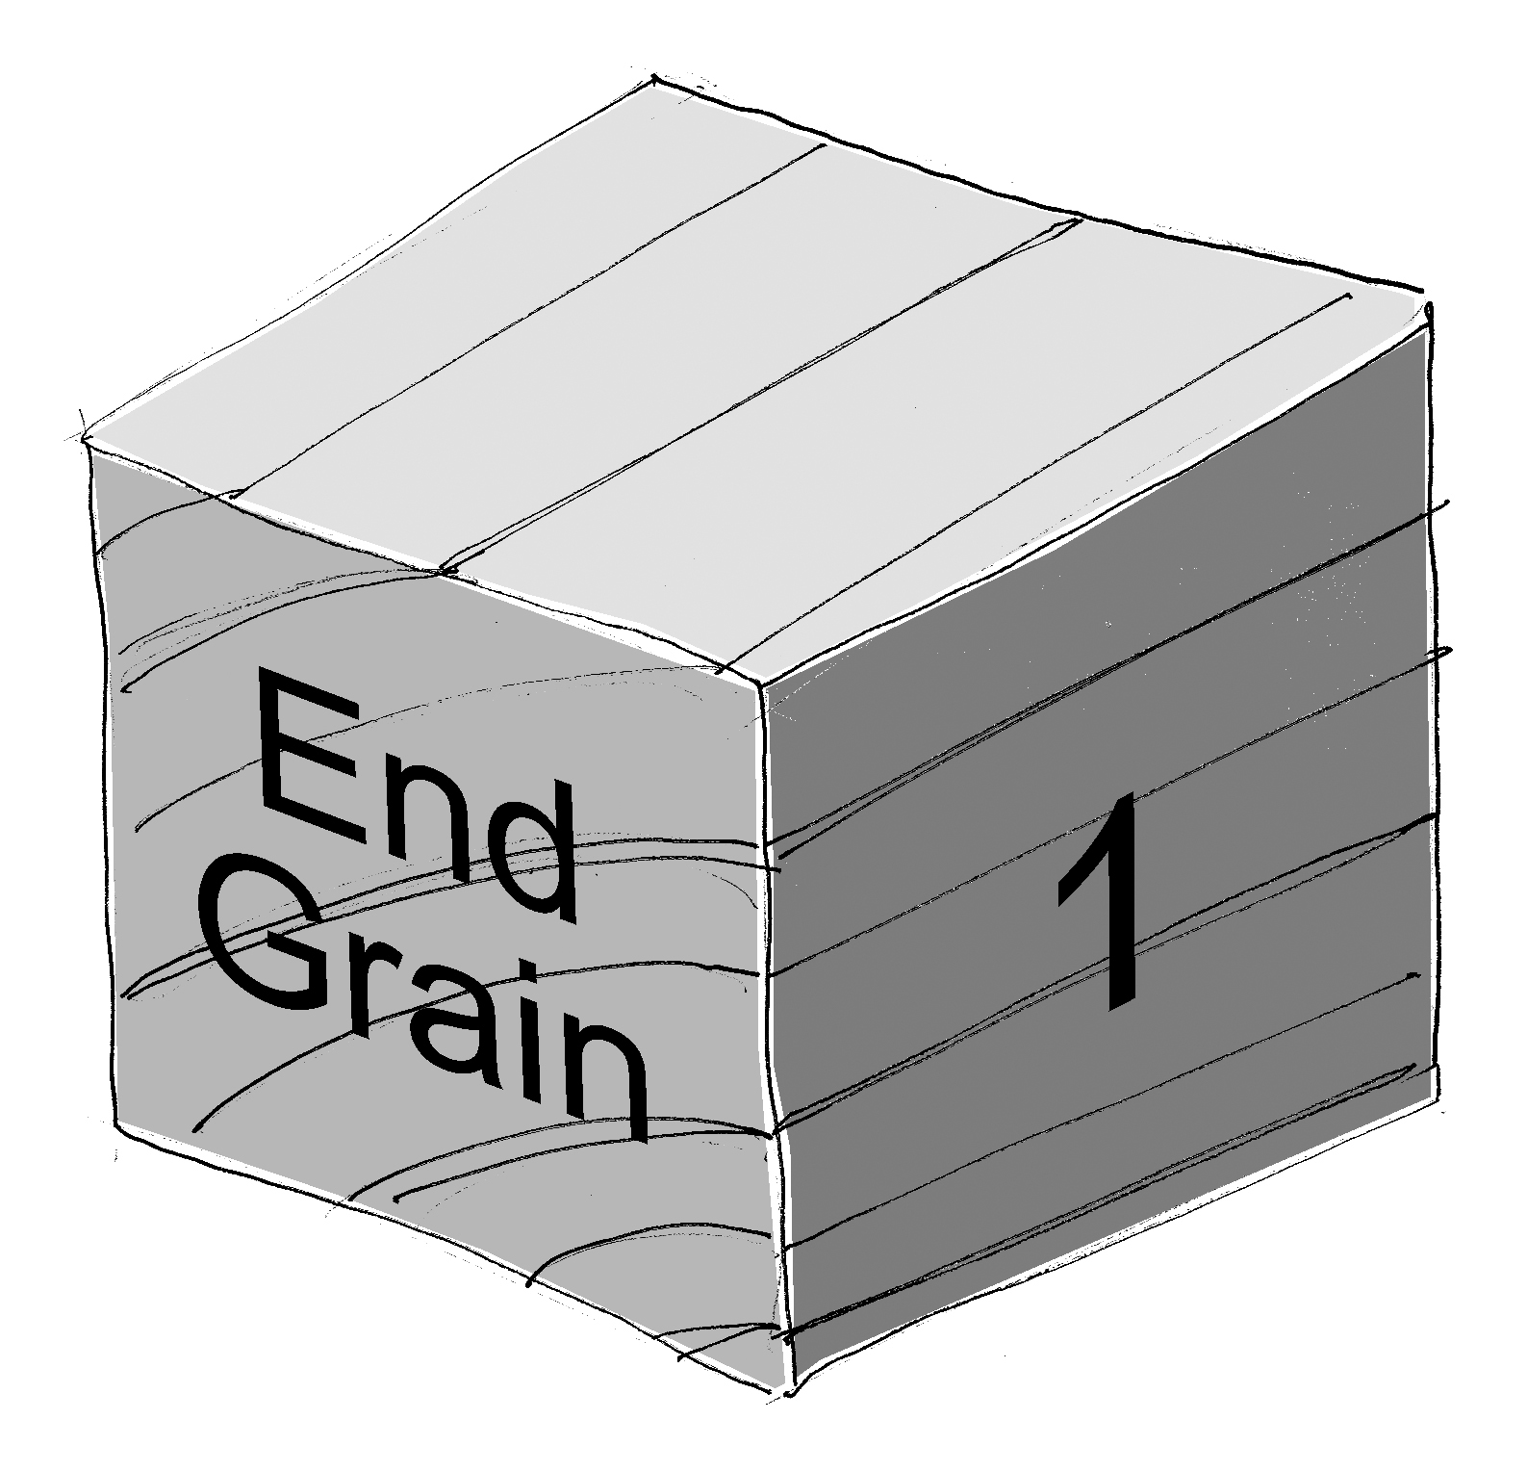

Measure the side length of each block along the grain. When taking a measurement, position the block so the caliper measuring surfaces are touching the end grain faces. Record the measurements to create a data set. Accuracy =.001 in

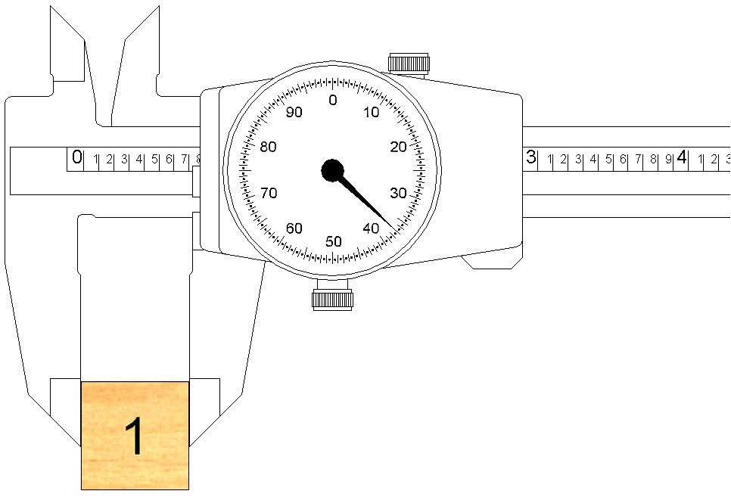

Wood cube 1: |  |  | Wood cube 15:
Wood cube 2: |  |  | Wood cube 16:
Wood cube 3: |  |  | Wood cube 17:
Wood cube 4: |  |  | Wood cube 18:
Wood cube 5: |  |  | Wood cube 19:
Wood cube 6: |  |  | Wood cube 20:
Wood cube 7: |  |  | Wood cube 21:
Wood cube 8: |  |  | Wood cube 22:
Wood cube 9: |  |  | Wood cube 23:
Wood cube 10: |  |  | Wood cube 24:
Wood cube 11: |  |  | Wood cube 25:
Wood cube 12: |  |  | Wood cube 26:
Wood cube 13: |  |  | Wood cube 27:
Wood cube 14:

- Calculate the following measures of central tendency for the set of cube measurement data. Show your work or explain your procedure for each.
Mean: ________________

Median: ________________

Mode: ________________

- Calculate each of the following measures of variation. Show your work.
    - Range: ________________

- Represent the data set with a histogram. Shade one square to represent the measurement of each cube.
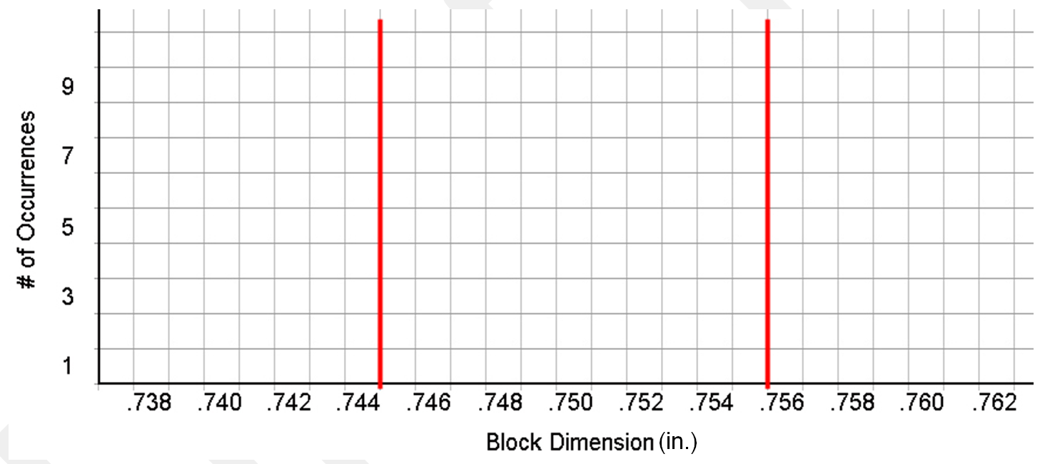
- Does your data appear to be normally distributed? Justify your answer.

- Assume that a block meets quality standards if the dimension along the grain is between 0.745 in. and 0.755 in.
  - Write the size constraint as a compound inequality.

  - What percentage of your sample blocks would be considered acceptable? Show your work.

- Assuming a normal distribution, how many of your side length measurements would you predict will fall within one standard deviation of the mean?

- From an ordered list what would you estimate to be the smallest side length measurement within one standard deviation of the mean? What would you estimate to be the largest side length measurement within one standard deviation of the mean?

- Challenge: Estimate the standard deviation of the side length of wooden blocks based on your data without actually performing the lengthy calculation. Hint: use the mean value and the answer to the previous question. You will have a chance to calculate the standard deviation using technology in Activity 3.5.

Conclusion
- You have calculated statistics related to your twenty seven wooden cubes. Consider how your statistical analysis results would change if all of the data values for all of the cubes measured by all of the students in your class were compiled and used for analysis. Then answer the following questions.
  - How would the histogram of the entire class’ data change compared to your histogram?

  - What value would you expect for the mean of the length measurements if the data from the entire class were used? Explain.

  - Would you expect the standard deviation of the class’ measurements be larger, smaller, or about the same as the standard deviation of your measurements? Why?

- In which phase(s) of a design process might statistics be most useful? Why?

- How can statistics of a product’s dimensions be used to assess the quality of the product?

